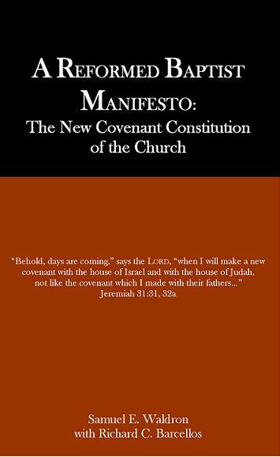

Waldron, Samuel; with Barcellos, Richard (2004) A Reformed Baptist Manifesto: the New Covenant Constitution of the Church. Palmdale, CA: Reformed Baptist Academic Press

This book demonstrates how only the Reformed Baptist view can account for a consistent exegesis of the New Covenant of Jeremiah 31:31-34 and its New Testament applications. The fact that the New Covenant is fully applied to the church even though made with “the house of Israel and Judah” refutes the Dispensational denial that the Church is the true Israel of faith. The fact that it promises to write the Law on hearts (instead of tablets of stone – cf 2 Corinthians 3:3) undermines all forms of Antinomianism that would set the Law up against Grace. The fact that the New Covenant of which Christ is mediator is not made with all but only those upon whom the Law is sovereignly written undermines the conditional-on-faith universal atonement view of Arminianism. Finally the fact the New Covenant is unbreakable and made only with the regenerate who have their sins forgiven and know the Lord refutes Paedobaptist claims that non-elect infants can be in and break the covenant. Only those giving credible evidence of being in it (namely faith and repentance) should be given its signs.

Appendices deal with some current issues at a more technical level. The first appendix refutes the attempts of some paedobaptists to project the fulfilment of the New Covenant into the eternal state to get a ‘not yet’ application for non-elect New Covenant members in the present. A second appendix interacts with New Covenant Theology and its understanding of the Law. (This is also available online at: http://www.rbtr.org/docs/Book%20Review%20NCT.htm )

Overall the book is excellent. One of its benefits is that it is not too long or technical to be of use to lay people. Indeed – the individual chapters can also stand alone.

Two minor issues are:
- In the chapter on Dispensationalism, Waldron refers to the church as the “New Israel” of the “New Covenant”. This may be true from the perspective of historical development - especially with regard the creation of visible churches since Pentecost. Theologically however, it is more accurate to say that the Church [universal] is the “True Israel” of faith. This Israel existed as the faithful remnant under the OT (Romans 9:6) - whom John the Baptist came baptising upon repentance. It is into this Israel that the Gentiles are engrafted by faith in Romans 11. Indeed – it is with this Israel-of-the-law-on-the-heart that the New Covenant is promised and fulfilled.
- Regarding the paedobaptist claim that the New Covenant can be broken, Waldron could also have made use of 1 John 2:19 which most clearly demonstrates that apostates are not covenant breakers – but rather show themselves to have never been in the New Covenant (as their apostasy demonstrates that the Law is not written on their hearts as they professed).

Aside from these minor issues, the book is highly recommended as an excellent and readable presentation of Reformed Baptist thought and how it is built on a clear exegesis of Scripture.

